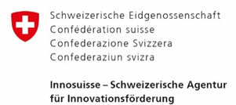
Short Profile of Participant(s)

Please provide short description of each participant about, working field, motivation to participate, goals, track record within this call topic, what resources (lab, financial, qualified staff) are available to participate in the project etc.
If applicable: Please specify and confirm requested independence between Swiss public research partner and private company according to Innosuisse eligibility rules .

Participant A
asdf

Participant B
asdf

Participant C
Asdf

Participant D
Asdf…

